Contoso Unified Customer Intelligence & Automation Platform Enterprise Design

1. Problem Framing & Objectives

Business Context
Contoso currently operates a multi-region Dynamics 365 Customer Service platform. However, the existing setup faces several challenges that hinder operational efficiency and data-driven decision-making.

Current Challenges:

- Fragmented reporting across regions and systems.
- Inconsistent Key Performance Indicators (KPIs) and definitions.
- Manual Service Level Agreement (SLA) escalations.
- Misuse of expensive CRM storage for attachments.
- Weak observability and monitoring of workflows.
- Security gaps in external integrations.

Constraints
- CRM production performance must not degrade.
- Multi-region scalability is required for all components.
- Cost-sensitive licensing models must be respected.
- Secure partner access to limited data/functionality is needed.

Objectives
The platform design aims to achieve the following:

- Establish a Governed Reporting Architecture.
- Define a Standardized KPI Framework.
- Implement Automated SLA Escalation.
- Design a Secure Identity Model for internal and external users.
- Implement Centralized Storage and Monitoring.
- Enable Data-Driven Service Optimization.

2. Enterprise Reporting Architecture – SSRS
Operational reporting for daily decision-making will be handled by SQL Server Reporting Services (SSRS) to ensure minimal impact on the production CRM environment.

Architecture
The architecture for operational reporting is as follows:

Dynamics 365 Production Database $\rightarrow$ Azure SQL Read Replica $\rightarrow$ SSRS

Operational reports will query the dedicated Azure SQL Read Replica to avoid contention and degradation of the Dynamics 365 production instance performance.

Report Design
Report Detail | Value
Report Title | Regional SLA Performance
Parameters | Region, Priority, SLA Status, Date Range
Key Features | Drill-through to case details, reusable datasets for consistency

Performance Strategy
To ensure reports load quickly and efficiently:

- Use Stored Procedures for optimized query execution.
- Index critical columns: RegionId, CreatedOn, Priority, SLAStatus.
- Apply Filtered WHERE clauses before large joins.
- Avoid using SELECT *.
- Implement Parameter Dependency (e.g., Region filter will automatically limit the available Agents list).

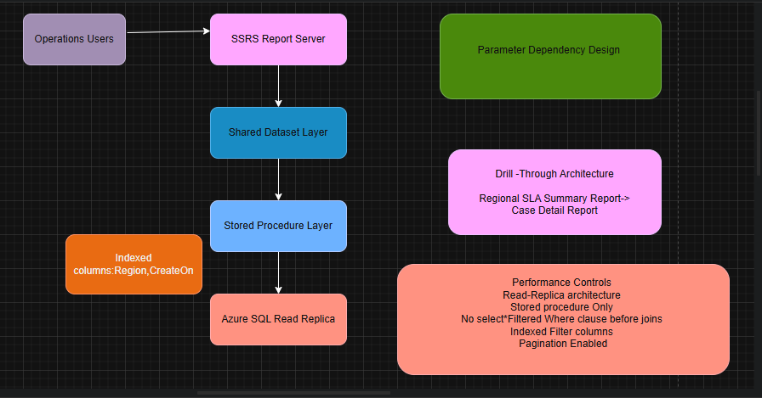

Why SSRS Over Power BI for Operational Reports
Criterion | SSRS | Power BI
Formatting | Pixel-perfect, fixed layout | Flexible, dynamic
Parameterization | Heavy and complex parametrization support | Good, but more focused on slicing
Export | Print-ready exports (e.g., PDF) | Best for interactive web/mobile viewing
Cost | Lower cost for large numbers of operational users | Pro license often required for sharing
Delivery | Subscription scheduling (email reports) | Primarily on-demand access

3. Executive Analytics & KPI Governance – Power BI
Power BI will be the platform for executive dashboards, advanced analytics, and centralized KPI governance.

KPI Governance
A centralized KPI definition sheet will be maintained, documenting:

- KPI Logic/Formula
- Data Owner
- Source System
- Refresh Frequency

Example KPI:

SLA Breach % = (Resolved cases exceeding SLA) / (Total resolved cases)

Dashboard Components
Component | Description
Case Volume Trend | Weekly/Monthly volume of incoming cases
SLA Breach Trend | Tracking the percentage of breaches over time
Average Resolution Time | Mean time from case creation to resolution
Region Comparison | Visual comparison of key metrics across regions
Priority vs Breach correlation | Identifying high-risk case types

Data Model
A Star Schema will be implemented:

Fact Table: FactCases (metrics like resolution time, breach status)
Dimension Tables: DimRegion, DimAgent, DimSLA, DimDate

DAX calculated measures will enforce consistent KPI definitions across all reports.

Governance
- Certified Dataset: A single, trusted dataset will be certified and used by all executive dashboards.
- Role-Level Security (RLS): Implemented to restrict agents/managers to data relevant to their region/team.
- Controlled workspace publishing managed by Person.

Refresh & Licensing
- Data ingestion mode: Import mode will be used for optimal dashboard performance.
- Pro Licensing: Limited to 8 refresh cycles per day.
- Premium Licensing: Required for near real-time analytics or higher refresh frequency.

Insight Example
Analysis of the Executive Analytics dashboard revealed that APAC shows elevated SLA breaches, which is correlated with a high concentration of high-priority backlog cases in that region.
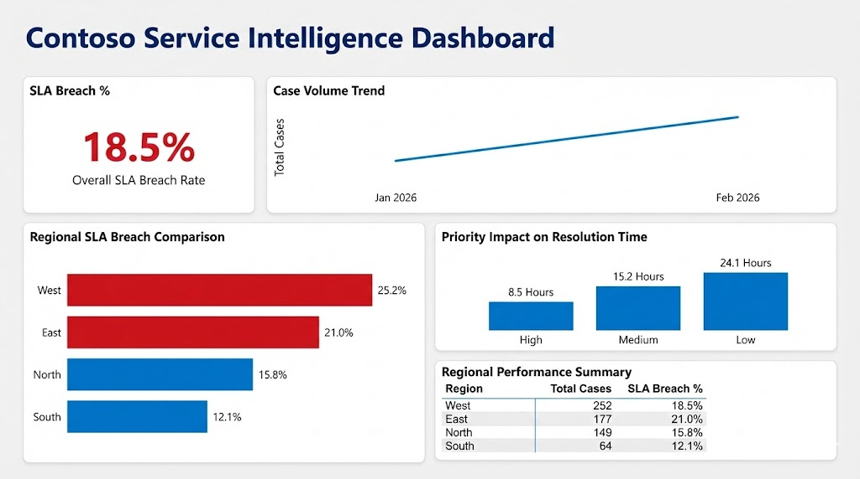

4. Secure Identity & External Access
A robust identity model is critical for securing both internal data and external partner access.

Identity Model
- Internal Users: Azure Active Directory (Azure AD) integrated with Role-Based Access Control (RBAC).
- External Partners: Azure AD B2C will be used to manage partner and vendor identities securely separate from the internal directory.

Authentication vs Authorization
Term | Definition
Authentication | Verifies the identity (e.g., checking password/MFA)
Authorization | Controls what the verified identity can access (via role claims)

Token Flow
- User login (Internal/External).
- A JSON Web Token (JWT) is issued by Azure AD/B2C.
- The API validates the JWT.
- The user's role is evaluated from the token claims.
- Access to specific resources is granted based on the role.

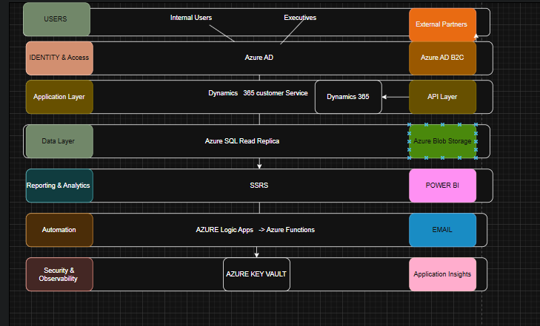

Risks & Mitigation
Risk | Mitigation Strategy
Token theft | Enforce HTTPS and set short token expiry times (e.g., 60 minutes)
Over-privilege | Strictly enforce Least Privilege RBAC model
Direct CRM exposure | Use an API abstraction layer (e.g., Azure API Management) to protect Dynamics 365

5. Automation & Exception Handling
Automation is crucial for achieving the objective of automated SLA escalation and consistent business logic execution.

Architecture
- Orchestration: Azure Logic Apps will manage workflow sequencing and external system integration.
- Business Logic: Azure Functions will host serverless code for complex, dynamic logic (e.g., dynamic threshold calculation).

SLA Escalation Flow
- Trigger: Dynamics 365 Case update (e.g., time remaining reaches 50%).
- Logic App checks SLA: Retrieves case details and current status.
- Azure Function calculates dynamic threshold: Determines the appropriate escalation level based on priority, region, and team capacity.
- Escalation notification sent: Notifies manager or next-level support via Teams/Email.

The specific calendar event for reviewing this SLA Escalation Flow is Calendar event.

Failure Handling
- Retry: Implement automatic retry with exponential backoff for transient failures.
- Timeout: Configure explicit timeout settings for external calls.
- Dead-letter: Use dead-letter handling (e.g., in Azure Storage Queue or Service Bus) for messages that fail final processing.
- Monitoring: Centralized monitoring via Application Insights.

When Not to Use Serverless (Logic Apps/Functions)
- Long-running processes (over 10 minutes for HTTP trigger).
- High-frequency, predictable workloads (better for dedicated VMs).

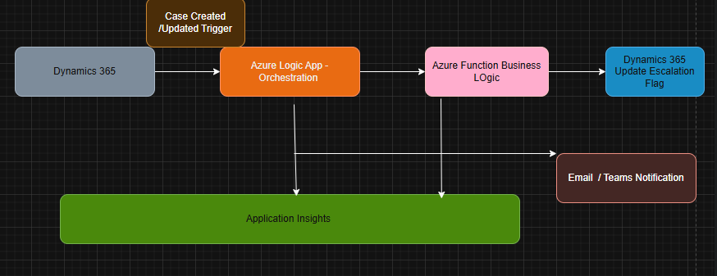

6. Storage, Secrets & Observability
Efficient storage, secure secrets management, and comprehensive observability are foundational.

Storage
- Attachments: Attachments will be moved from Dynamics 365 to Azure Blob Storage to minimize expensive CRM storage consumption.
- CRM: Dynamics 365 will only store the metadata and a secure URL link to the attachment in Blob Storage.

Secrets
- Key Vault: Azure Key Vault will securely store all application secrets (API keys, connection strings, certificates).
- Managed Identity: Managed Identity will be used to grant Azure resources (Logic Apps, Functions) secure access to Key Vault secrets without storing credentials in code.

Monitoring (Application Insights)
Application Insights will track key operational health metrics:

- Workflow failures (Logic App/Function errors).
- SLA breach rate (Custom metric).
- API latency.
- Report failures (SSRS/Power BI).

Alerts:

- SLA breach rate above threshold (e.g., 5%).
- Logic App failure spike.
- Storage anomaly (e.g., high ingress/egress).

7. Analytical Thinking & Optimization

Problem Framing
The objective of this analysis is to evaluate SLA compliance performance across regions, understand workload distribution, and identify operational inefficiencies impacting service quality.

Analytical Questions
Which region has the highest SLA breach percentage?
Is rising case volume contributing to SLA breaches?
Does case priority influence resolution time?
Which region carries the highest workload burden?

Insights Derived from Dashboard
Metric | Detail | Interpretation
Overall SLA Breach Rate | 18.5 percent | Suggests systemic operational pressure rather than isolated incidents.
Regional Performance Variance | West: 25.2%; East: 21.0%; North: 15.8%; South: 12.1% | Indicates performance imbalance across regions, with West region being the highest risk.
Case Volume Trend | Increasing from January to February 2026 | Rising workload without proportional capacity increase may be contributing to breach escalation.
Priority Impact on Resolution Time | Low: 24.1 hours; Medium: 15.2 hours; High: 8.5 hours | Prioritization logic is effective, but lower priority backlog accumulation may create long-term service degradation risk.
Workload Concentration | West: 252 cases; South: 64 cases | Uneven case distribution may be driving SLA non-compliance in the West region.

Root Cause Interpretation
SLA breaches are strongly correlated with high regional case volume.

Operational capacity imbalance is likely present in West and East regions.

Increasing case trend suggests scaling pressure.

Backlog accumulation in lower priority cases may create delayed spillover effects.

Business Recommendations
Implement workload redistribution between regions to balance capacity.

Introduce early-warning alerts when regional breach exceeds 20 percent.

Review staffing allocation for the West region.

Introduce dynamic SLA threshold monitoring during peak periods.

Conduct monthly KPI governance review to monitor trend changes.

Risks & Future Improvements
Dashboard does not include agent-level productivity metrics.

No visibility into root operational causes such as staffing or shift coverage.

Future enhancement should include predictive breach modeling based on case inflow patterns.

Incorporate customer satisfaction metrics to align SLA with service perception.

